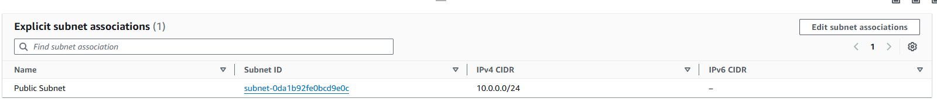

https://54.152.165.244/